Aster Analyzer

© 2016-9 Kanchanawong Lab, Mechanobiology Institute, National University of Singapore

www.nanoscalemechanobiology.org

**Table of Contents**

1. Installation

2. Quick-Start

3. List of Functionalities

4. Howtos

**1. Installation**

**1.1** ***IDL installation***

AsterAnalyzer is developed using IDL version 8.2. To run AsterAnalyzer, IDL 8.2 or later should be installed per vendor’s instructions. https://www.harrisgeospatial.com/Software-Technology/IDL

AsterAnalyzer 1.0 has been tested only on Windows 7 Enterprise (64-bit), but should be usable on Linux and MacOS (may require modification of GUI organization).

**1.2** ***Calling MeshworksAnalyzer as VM***

Compiled machine code for AsterAnalyzer is in AsterAnalyzer.sav and can be called once IDL is installed

**1.3** ***Source code***

Users may choose to modify the provided source code and recompiled as necessary. This requires a fully licensed version of IDL. Additional libraries used extensively are David Fanning’s Coyote Graphics. < http://www.idlcoyote.com/>

**2. Quick-Start**

**2.0** ***Prerequisites and Introduction***

* This version requires images are captured as a stack monochrome 16-bit TIFF file. You may use ImageJ to combine multiple images into a stack

* All data will be saved into ***asters.sav file which is IDL format.

**2.1** ***Loading and Saving Files***

To start the analysis:

i. I/O tab > Load *.tiff

*Load raw image, Scroll the bottom scroll bar to move between frames*

ii. I/O tab > Save analysis to *asters.sav

*Save the work file into the default format.*

Make sure to save the file often during processing.

**2.2** ***Defining and Editing ROIs***

i. Select the ROI to analyze

Main tab > Define analysis ROI

ii. Edit the ROI

Main tab > Edit analysis ROI

iii. If needed, the ROI can be reset for current frames or all frames

Main tab > Reset ROI, current frame

Main tab > Reset ROI, all frames

iv. For instruction on defining and editing ROI, see Howtos below.

vi. I/O tab > Save analysis to *asters.sav

*Save the work file*

**2.3** ***Visualization***

i. Different color scale can be chosen

Main tab > Color

ii. Different display mode can be chosen

Main tab> Display

Raw, mask, and overlay

**2.4** ***Asters Detection***

i. Asters Detection tab > Auto. Parameters (PSF)

This will detect PSF-sized spot. Based on single-molecule localization algorithm but probably not very useful for Asters.

ii Asters Detection tab > Mode

Detection mode: if mask (ROI) is available, detect asters only in masked area

Or ignore the mask

iii. specify Numbers of asters to locate by

Asters Detection tab >Maximum Asters number to detect

iv. Asters Detection tab > Detect Asters

Detect asters in the current frame per the specified parameters in the scroll box

v. Asters Detection tab > Detect Asters, All Images

If the results seem reasonable, detect asters in all frames per the specified parameters in the scroll box

vi. Detected asters would be tabulated in the table on Asters Analysis tab.

See **howtos** below for more info on how to perform various tasks

**3.** **List of Functionalities**

**3.1 *Main Display***

3.1.1 The main display is 1024x1024. Selection is by click-and- drag to zoom (only square selection is allowed). Scroll bar allow moving between different frames.

3.1.2 Main tab > Unzoomed

*Return to default unzoomed state*

3.1.3 Main tab > Clear Screen

*Make the screen blank (zoom is not affected)*

3.1.4 Main tab > Refresh

*Replot the current zoom level*

3.1.5 Main tab > Copy Current Screen

*Copy the content of main display and show in a new window. Useful as ‘scratch pad’ for comparing different areas.*

3.1.6 Main tab > Save Current Screen

*Save the current screen as .tif file*

3.1.7 Main tab > EXIT

*Exit the program*

**3.2 I/O Tab**

3.2.1 I/O tab > Load *.tiff

*Load raw image*

3.2.2. I/O tab > Load analysis from *asters.sav

*Load the work file saved in previous session*

3.2.3. I/O tab > Save analysis to *asters.sav

*Save the work file into the default format.*

**3.3 Asters Detection Tab**

3.3.1 i. Asters Detection tab > Auto. Parameters (PSF)

*This will detect PSF-sized spot. Based on single-molecule localization algorithm but probably not very useful for Asters.*

3.3.2 Asters Detection tab > Detect Asters

*Detect asters in the current frame per the specified parameters in the scroll box*

3.3.3 Asters Detection tab > Mode

*Detection mode: if mask is available, detect asters only in masked area*

*Or ignore the mask*

3.3.4 Asters Detection tab > Detect Asters, All Images

*Detect asters in all frames per the specified parameters in the scroll box*

3.3.5 Asters Detection tab >Gaussian Sigma (pixel)

*Sigma parameter for the difference of Gaussian detection kernel in pixel unit*

3.3.6 Asters Detection tab >Window Radius (pixel)

*Radius of detection window (size = 2*radius+1) in pixel*

3.3.7 Asters Detection tab >Maximum Asters number to detect

*Numbers of asters to locate*

3.3.8 Asters Detection tab >Emission Wavelength (nm)

*Relevant for PSF mode*

3.3.9 Asters Detection tab >Camera pixel size (um)

*Relevant for PSF mode*

3.3.10 Asters Detection tab >Magnification (X)

*Relevant for PSF mode*

3.3.11 Asters Detection tab >Numerical Aperture (N.A.)

*Relevant for PSF mode*

3.3.12 Asters Detection tab >Camera Dark Offset (Gray Level)

*Zero off set of the camera. Check spec sheet of the camera.*

**3.4** **Asters Analysis Tab**

3.4.1 Asters Analysis tab > Refresh

*Replot the screen*

3.4.2 Asters Analysis tab > Plot All Asters

*Plot all asters in field of view*

3.4.3 Asters Analysis tab > Aster neighbourhood radius (pixel)

*Radius of asters neighbourhood*

3.4.4 Asters Analysis tab > Locate Asters

*Locate selected asters*

3.4.5 Asters Analysis tab > Aster Properties

*Plot Aster properties*

3.4.6 Asters Analysis tab > Remove Asters

*Remove asters at selected row from table*

3.4.7 Asters Analysis tab > Refresh Table

*Update table*

3.4.8 Asters Analysis tab > Export Table

*Export table to *.csv text file*

3.4.9 Asters Analysis tab > Sort Table

*Sort by selected column*

3.4.10 Asters Analysis tab > Reject Bad Asters

*Remove all asters with poor fit*

3.4.11 Asters Analysis tab > Remove by ID:

*Remove asters by specified ID*

3.4.12 Asters Analysis tab > Histogram/Col.

*Plot histogram of selected column*

3.4.13 Asters Analysis tab > Statistics I

*Plot statistics of asters, part I*

3.4.13 Asters Analysis tab > Statistics II

*Plot statistics of asters, part II*

**3.5 Table of Asters**

|  |  |  |
| --- | --- | --- |
| # | Column | Description |
| 1 | ID | ID of Aster, starting from 1 |
| 2 | X | x-position (pixel) |
| 3 | Y | y-position (pixel) |
| 4 | Max Peak Value | Maximum intensity in peak |
| 5 | Mean Background | Average intensity of the background (cortex) |
| 6 | Mean P/B | Mean peak/Mean background ratio |
| 7 | Mean Peak Value | Mean Intensity in peak |
| 8 | Background Sigma | Standard deviation of background |
| 9 | Background Threshold |  |
| 10 | Max P/B | Max peak intensity/mean background |
| 11 | x-Fit | X-Centroid of asters/ 2D Gaussian fit |
| 12 | y-fit | Y-Centroid of asters/ 2D Gaussian fit |
| 13 | Sigma X | X-width/ 2D Gaussian fit |
| 14 | Sigma Y | Y-width/ 2D Gaussian fit |
| 15 | Amplitude | Amplitude / 2D Gaussian fit |
| 16 | Offset | Offset / 2D Gaussian fit |
| 17 | Area | Aster area above threshold |
| 18 | Area.intensity | Product of area and intensity |
| 19 | Ellipticity | Ellipticity of asters |

**4. Howtos**

4.1 ***How to define and edit ROI for analysis , for asters definition, and for filament curation***

4.1.1 Main tab > Define Analysis ROI

*Call up Interactive segmentation tools for defining ROI for meshwork analysis*

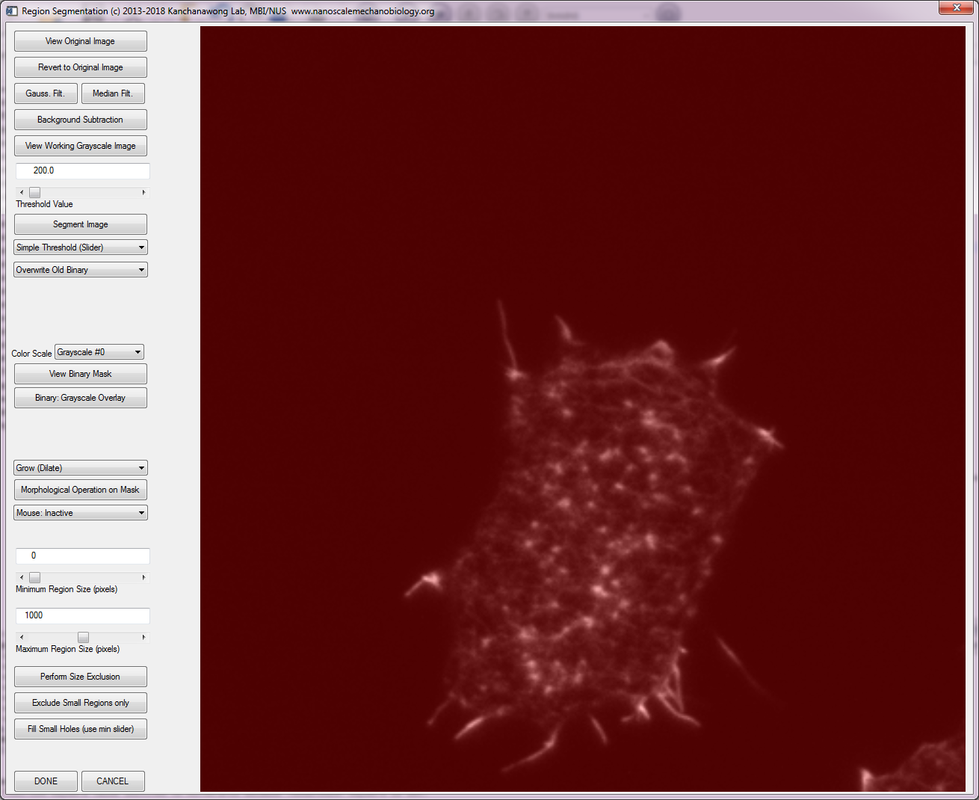

4.1.2 Choose Threshold Value and click Segment Image

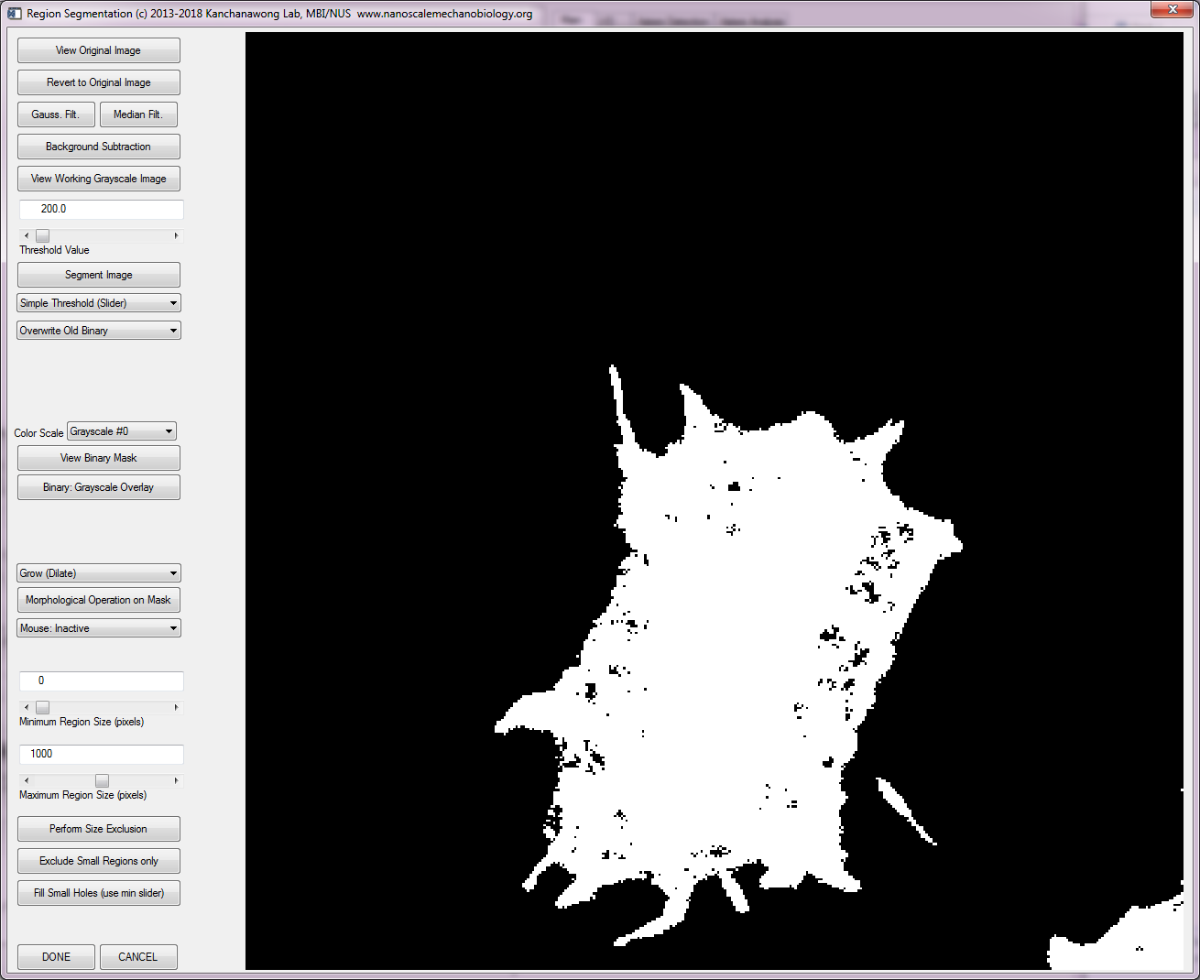

4.1.3 Multiple filtering/thresholding options are available

4.1.3.1 Image can be Gaussian or median filter

4.1.3.2 Background subtraction can be performed

4.1.3.3 Different threshold methods available (simple: specified value, Otsu, mean, IsoData, Moments, MaximumEntropy, Min-Error)

4.1.4 Morphological operations can be performed on binarized image

4.1.4.1 Minimum and maximum pixel size limits can be defined

4.1.4.2 Size exclusion (keep only ROI within the range) / exclude small region only / or fill in small holes

4.1.4.3 Dilate, Erode, Close, or Open operations can be performed

4.1.5 To exit, click DONE

4.1.6 Usually, editing of ROI is needed.

Image Processing tab > Edit Analysis ROI

*A window for editing ROI will appear*

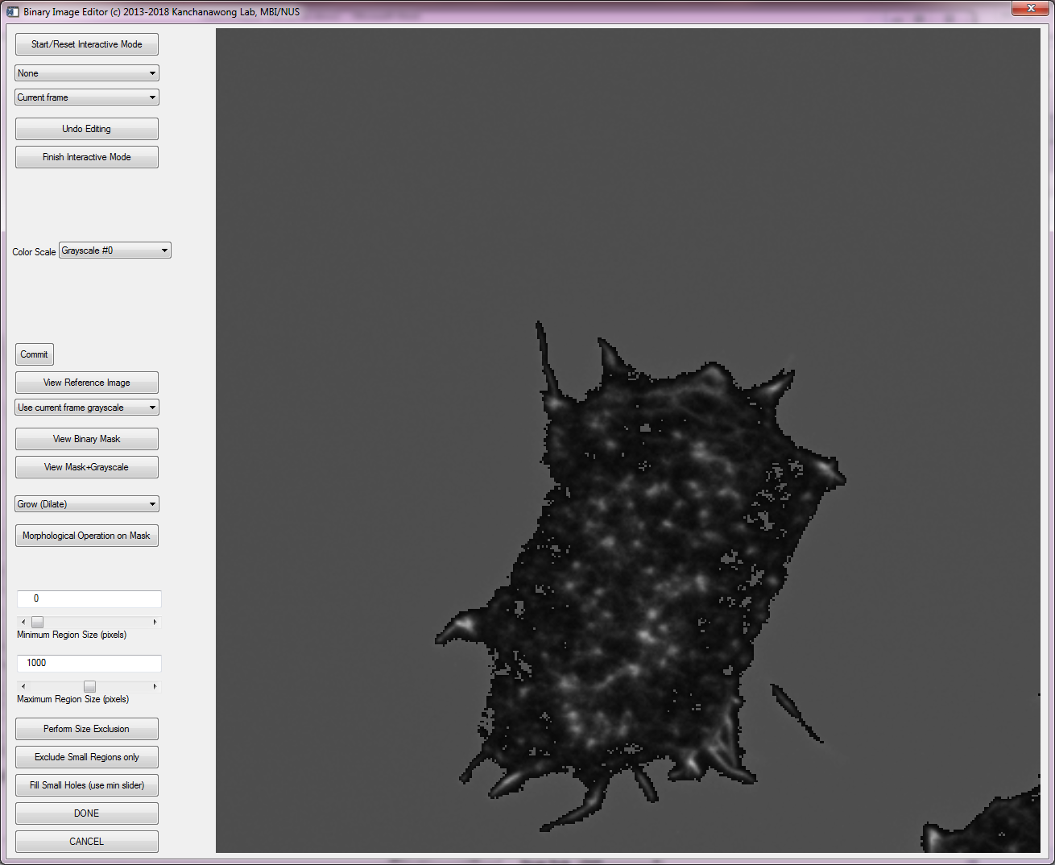

4.1.7 In addition to morphological operations and size exclusion described above, manual editing can be performed

>>Choose Draw Area to Add

Right click to define region to select

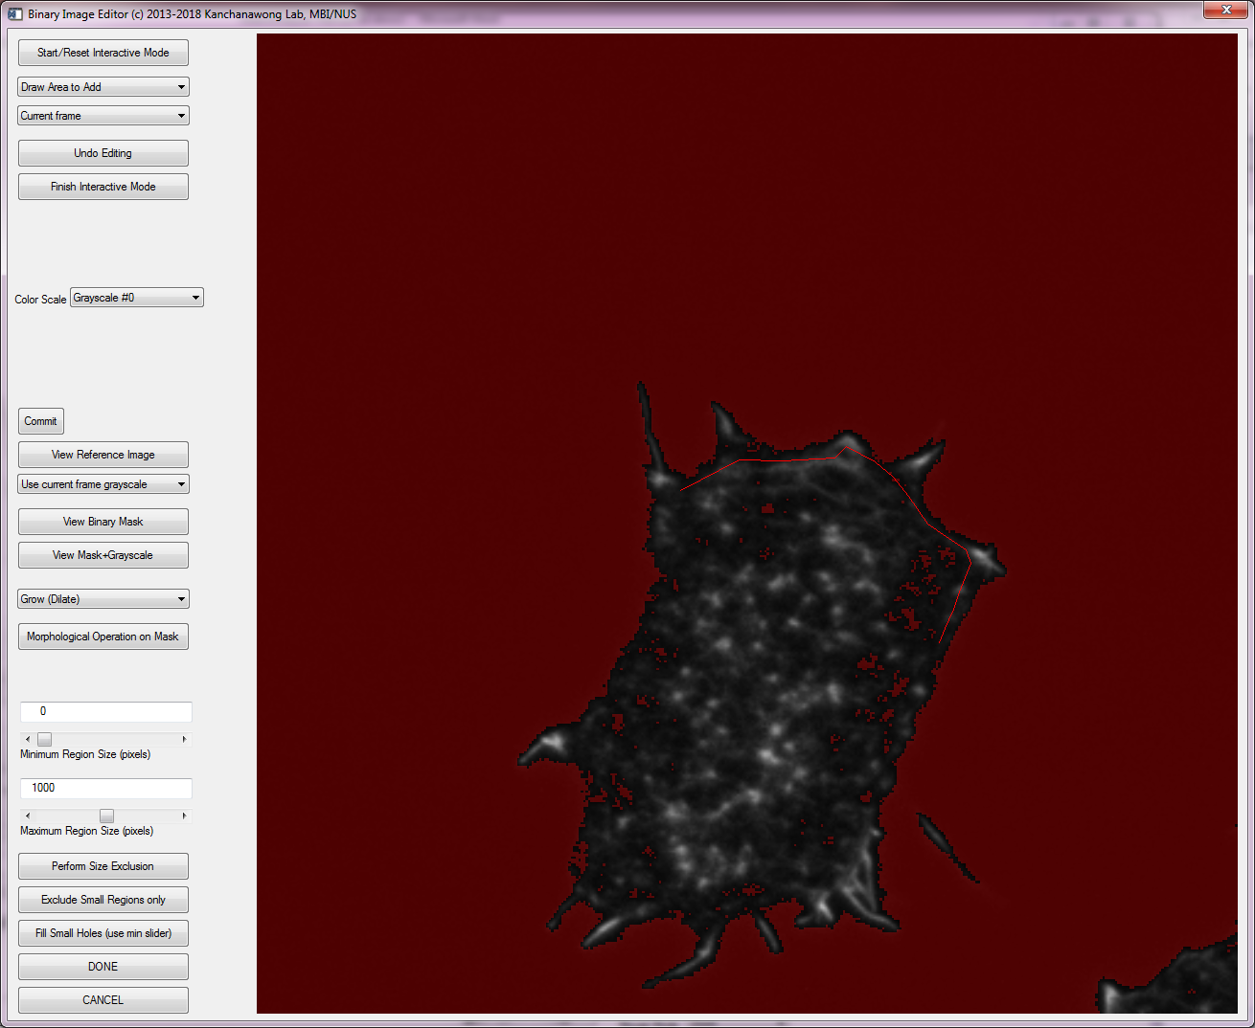

4.1.8 When satisfied, middle click to close the ROI

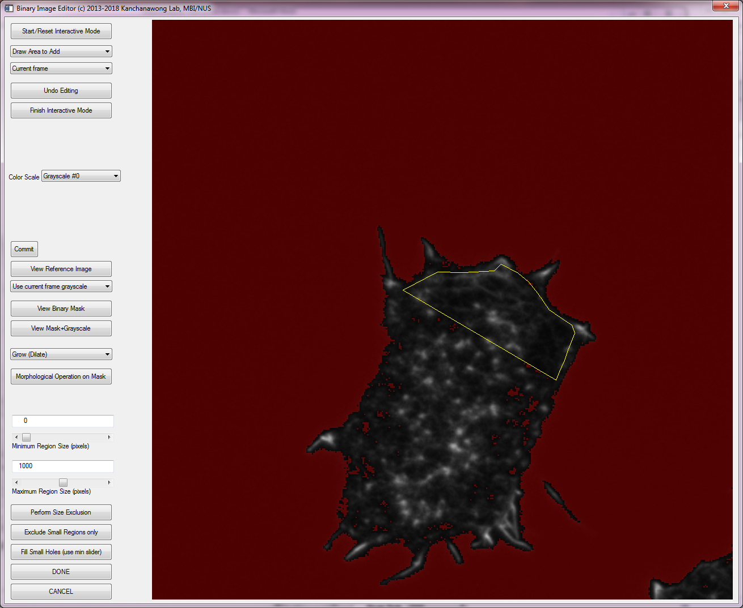

4.1.9 To remove an area, choose draw area to remove. ROI can be defined similarly as above/

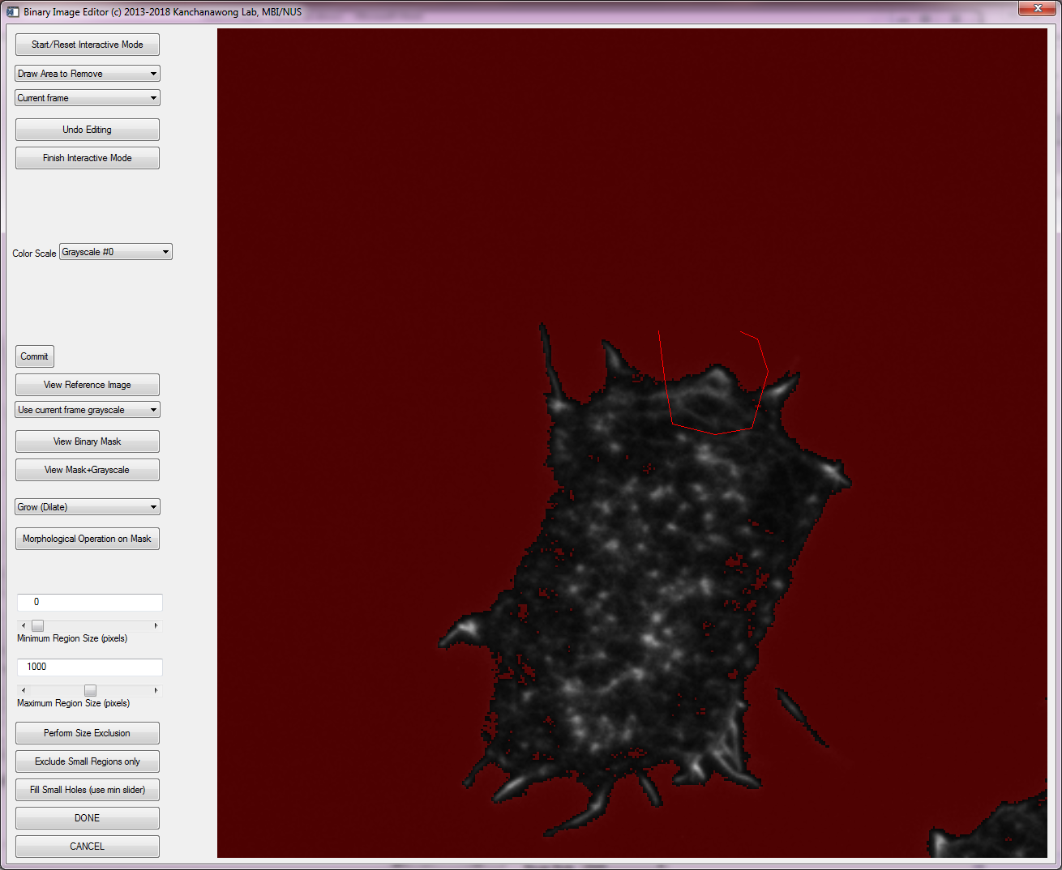

4.1.10 The removed area is now subtracted out

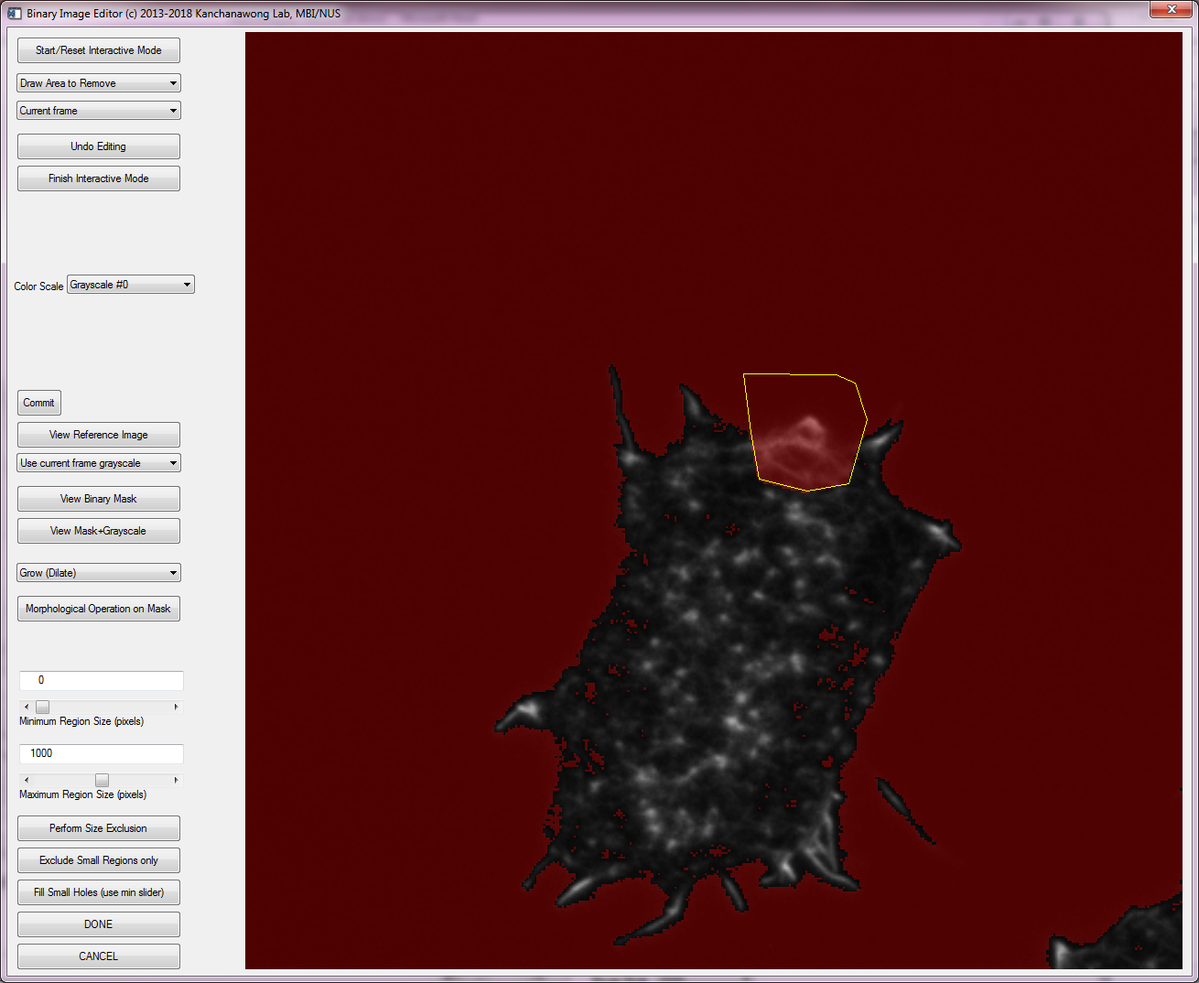

4.1.11 Once satisfied area is defined, click ‘DONE’ and save the data file.

4.1.12 Scroll to other frame and repeat for all images

4.1.13 Make sure to save the work file

4.2 ***How to detect and analyze asters***

4.2.1 Perform Step 2.1-2.4

The asters will be shown marked by green cross, overlayed on filtered image. Only asters that fall within the ROI (bottom inset right) will be included in the asters table.

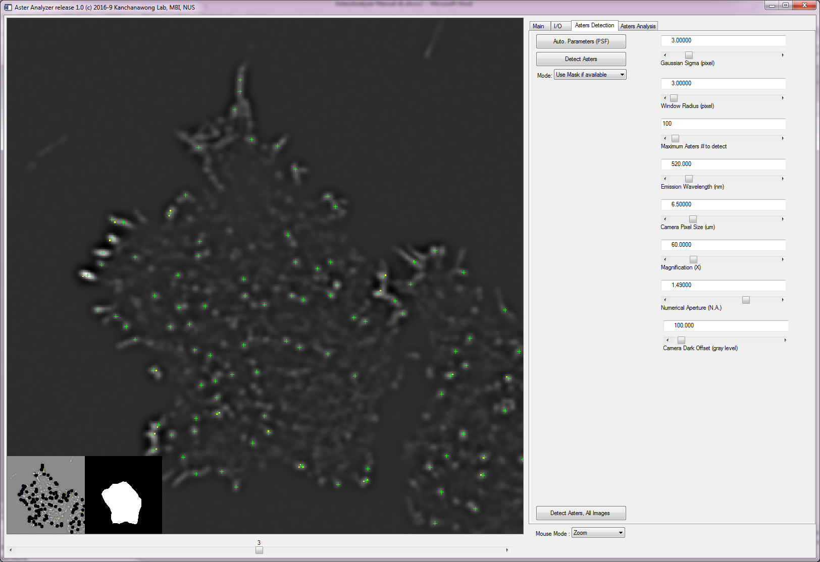

4.2.2 The asters for each frame will be shown in the table in the asters analysis tab. Use the scroll bar to move between frames. Plot all Asters will mark all asters

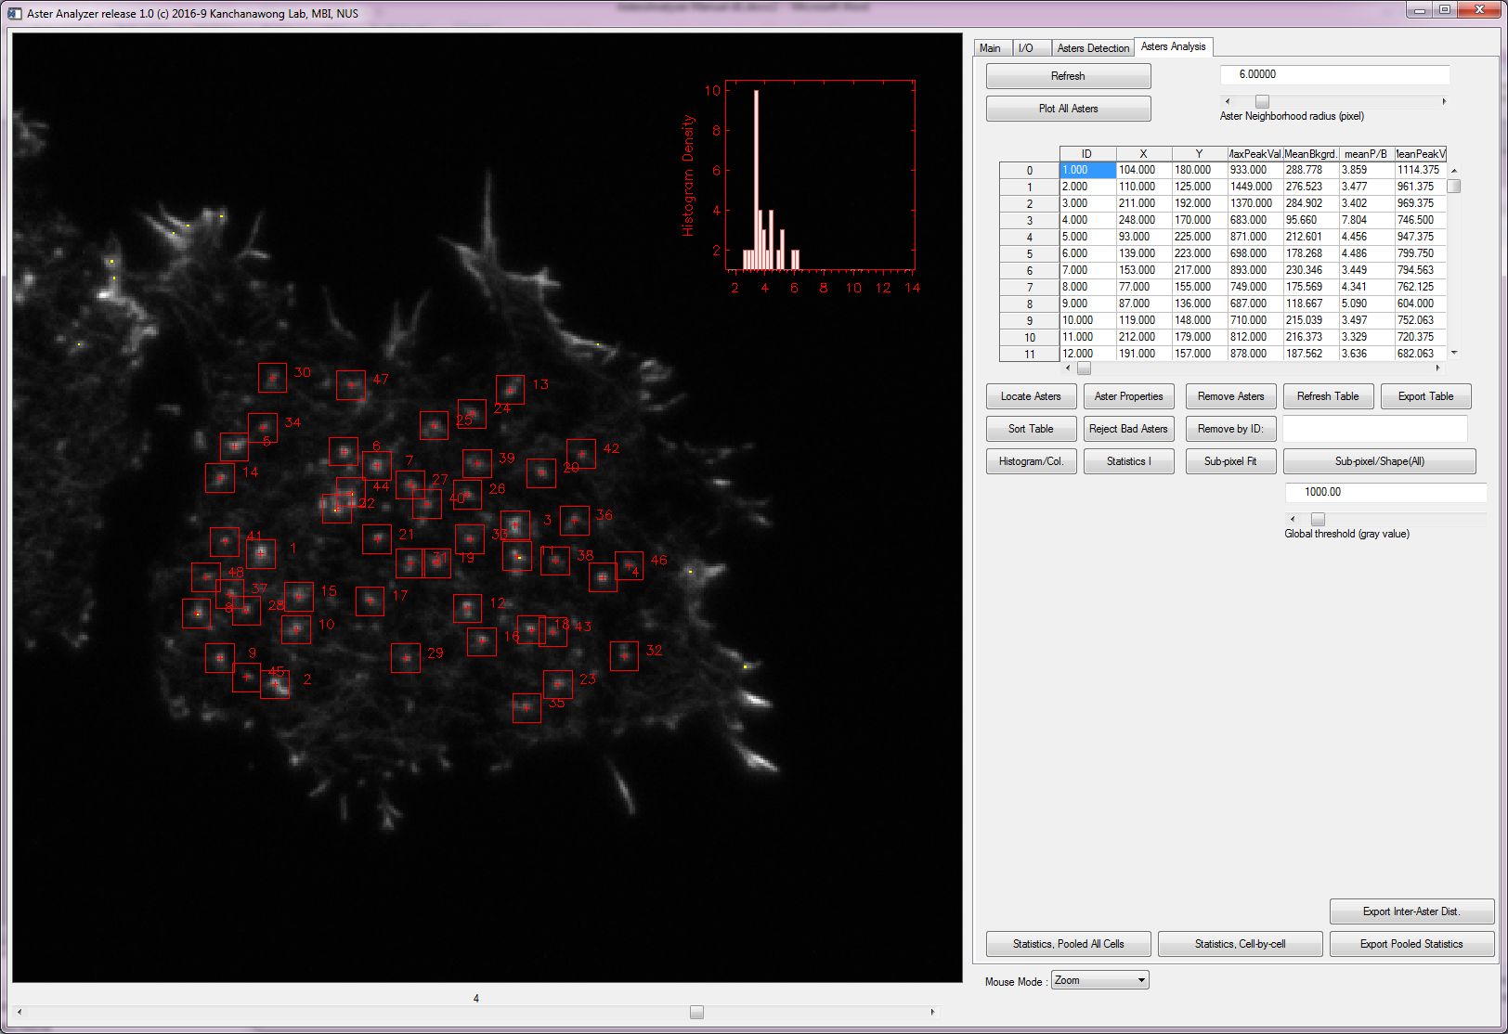

4.2.3 If the asters are not satisfactory (too few), go back to 2.1-2.4 and increase maximum asters #

4.2.4 If there are too many false asters, either go back to 2.1-2.4 and reduce maximum asters # or manually reject the asters

4.2.4.1 Select the table of desired properties, e.g. MeanBkgnd

Click Sort Table. Then visualize histogram by clicking Histogram/Col.

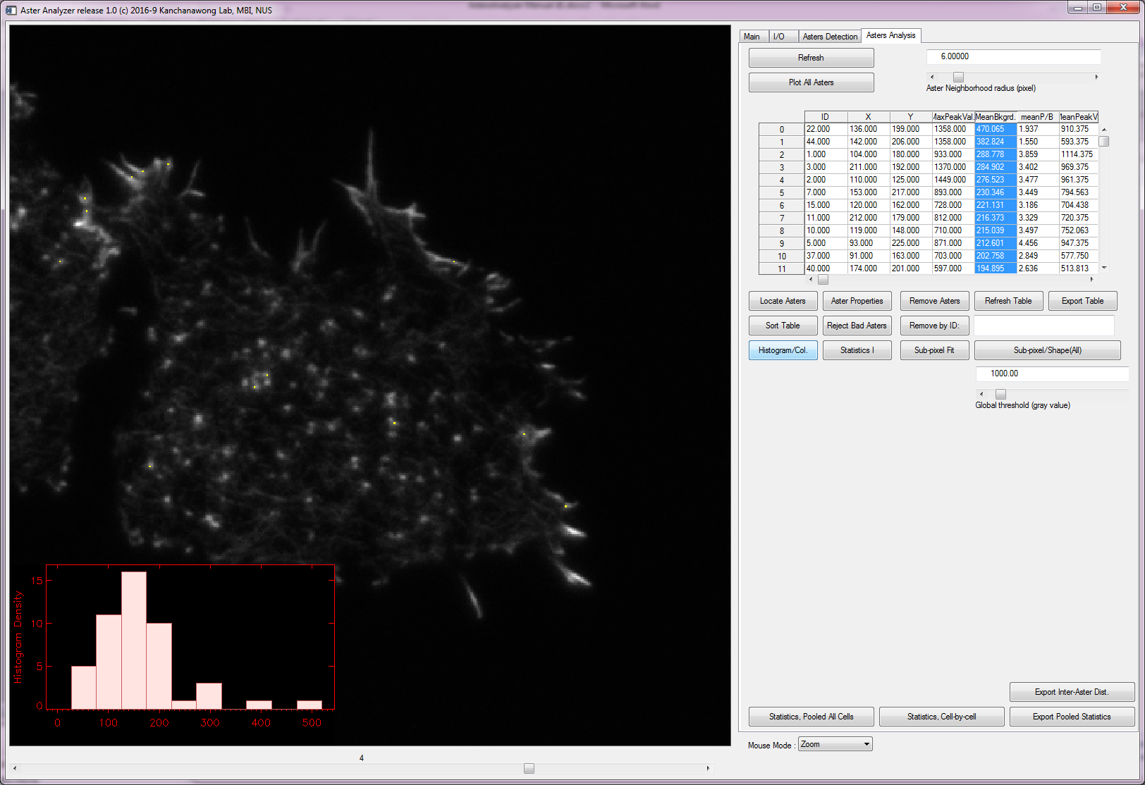

4.2.4.2 In this example the aster with highest background is ~470

4.2.4.3 Select this row, and click Locate Asters. The asters will be highlighted.

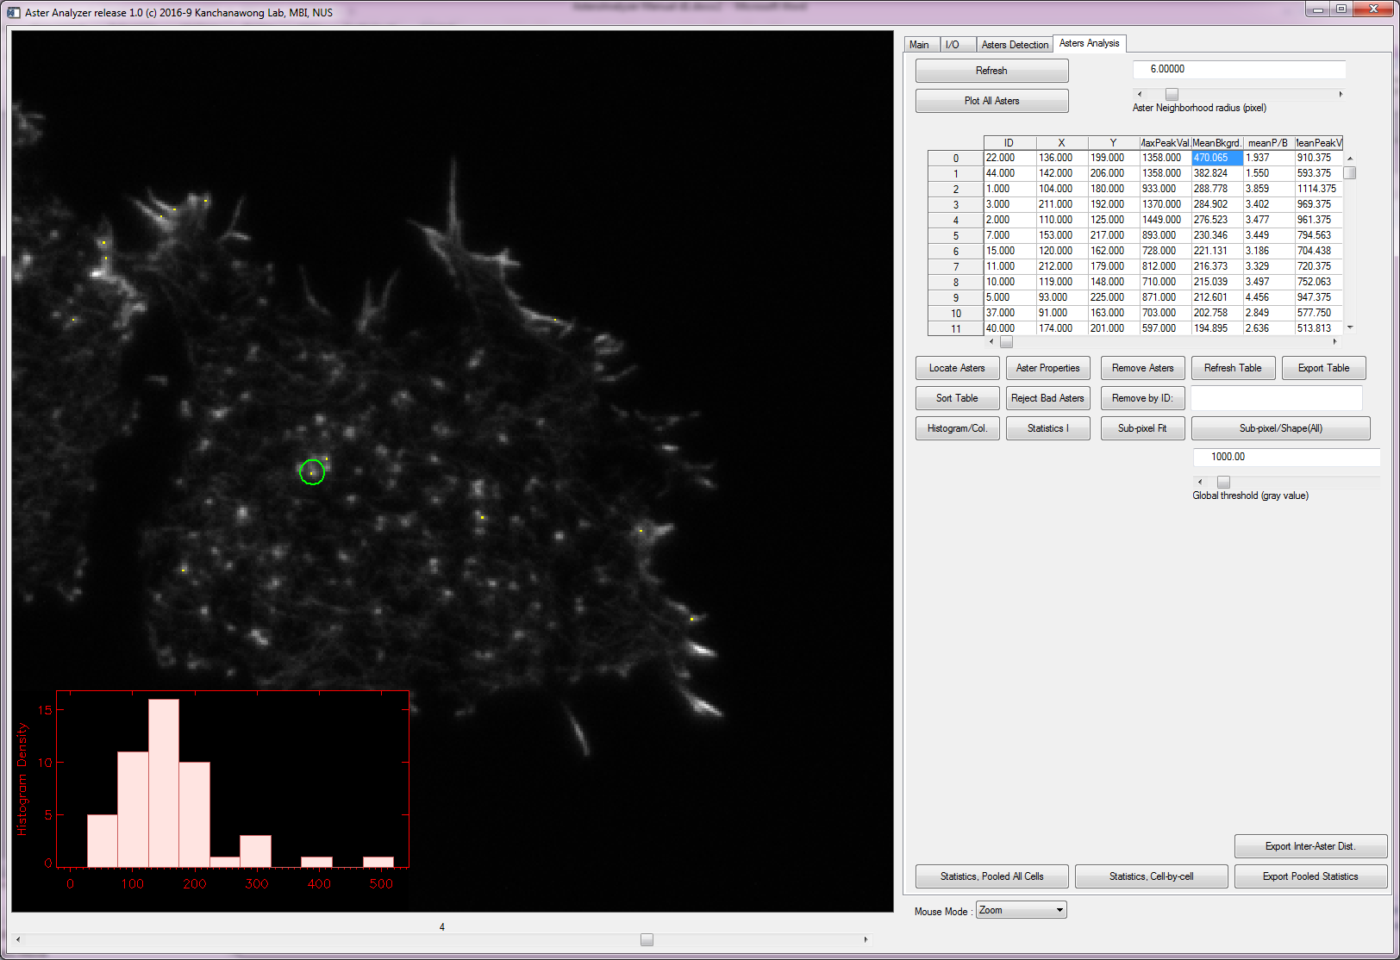

4.2.4.4 If the asters look bad, click remove asters. Alternatively asters can be removed by specifying the aster ID in the text box

4.2.5 To perform further shape analysis, click Sub-pixel Fit

What’s shown are the raw data, 2D Gaussian fit and residuals, respectively.

To perform shape analysis, define the threshold for the shape in the Global Threshpld scrollbox.

To fill in all the columns in the table click Sub-pixel/Shape (All).

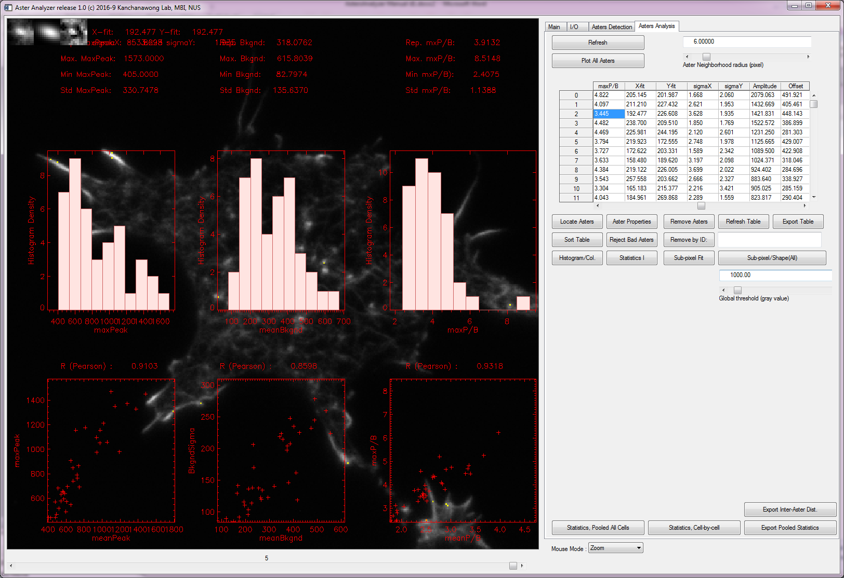

4.2.6 Clicking ‘Statistics I’ will show some key properties

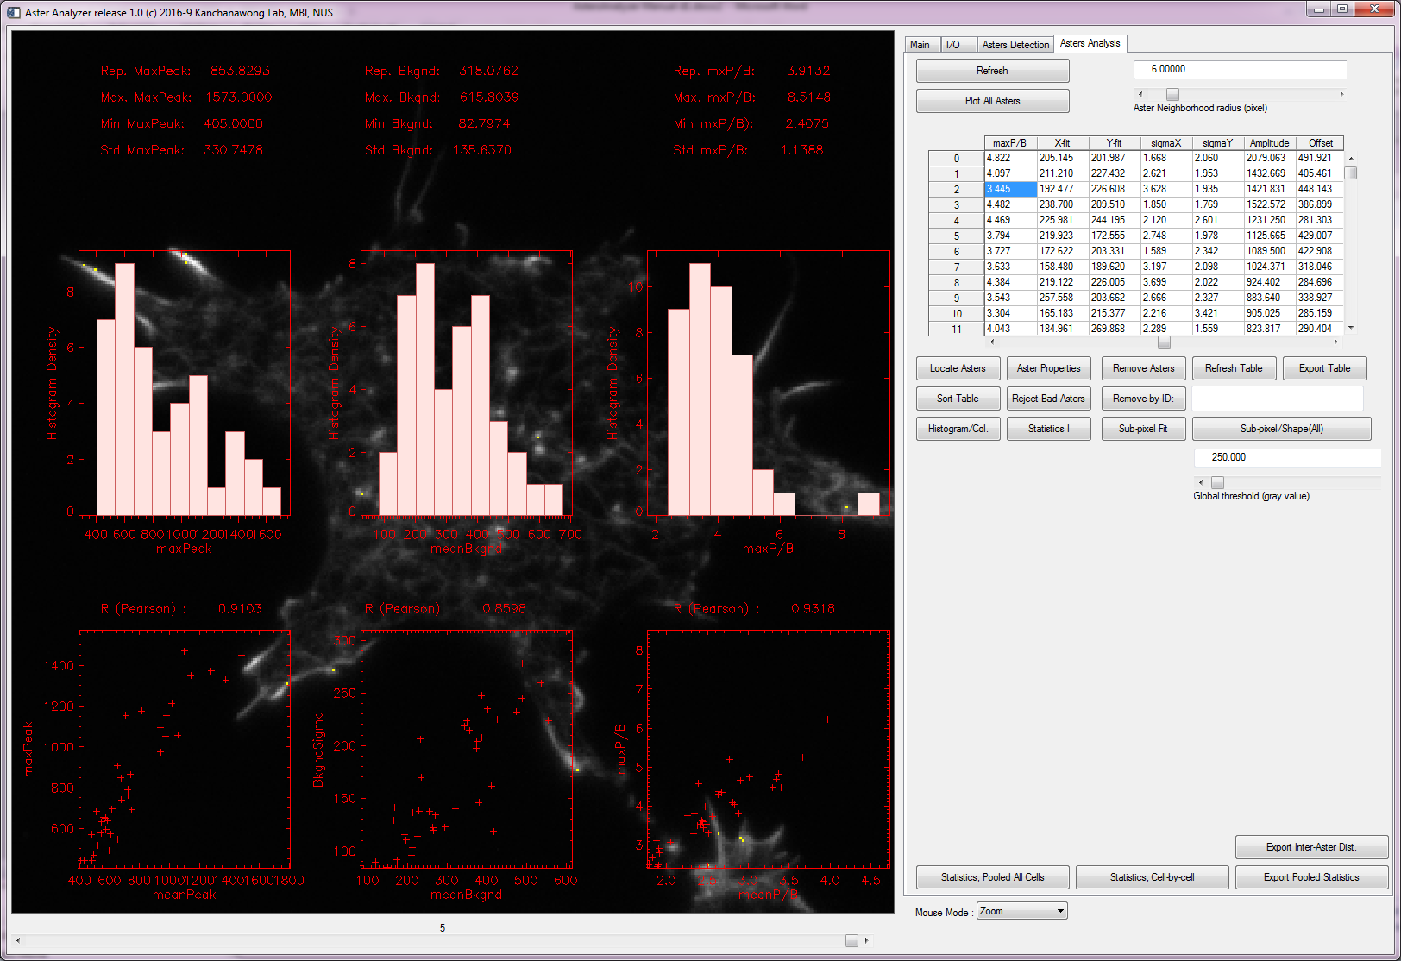

4.2.7 Clicking ‘Statistics, Pooled All Cells’ will show key properties, pooled from all frames

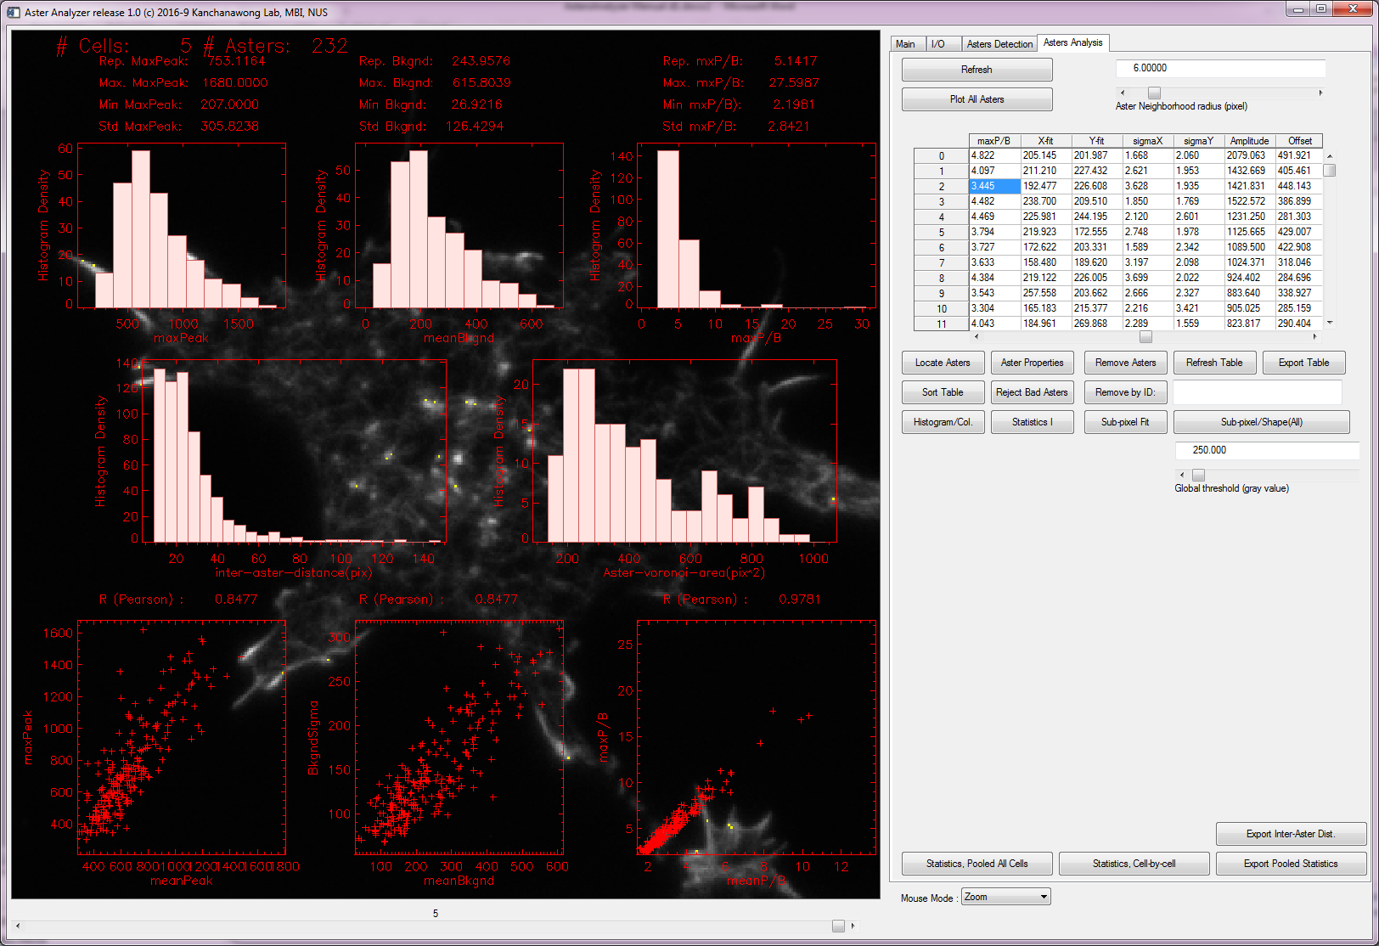

4.2.8 click ‘Export Pooled Statistics’ to output to .csv text file